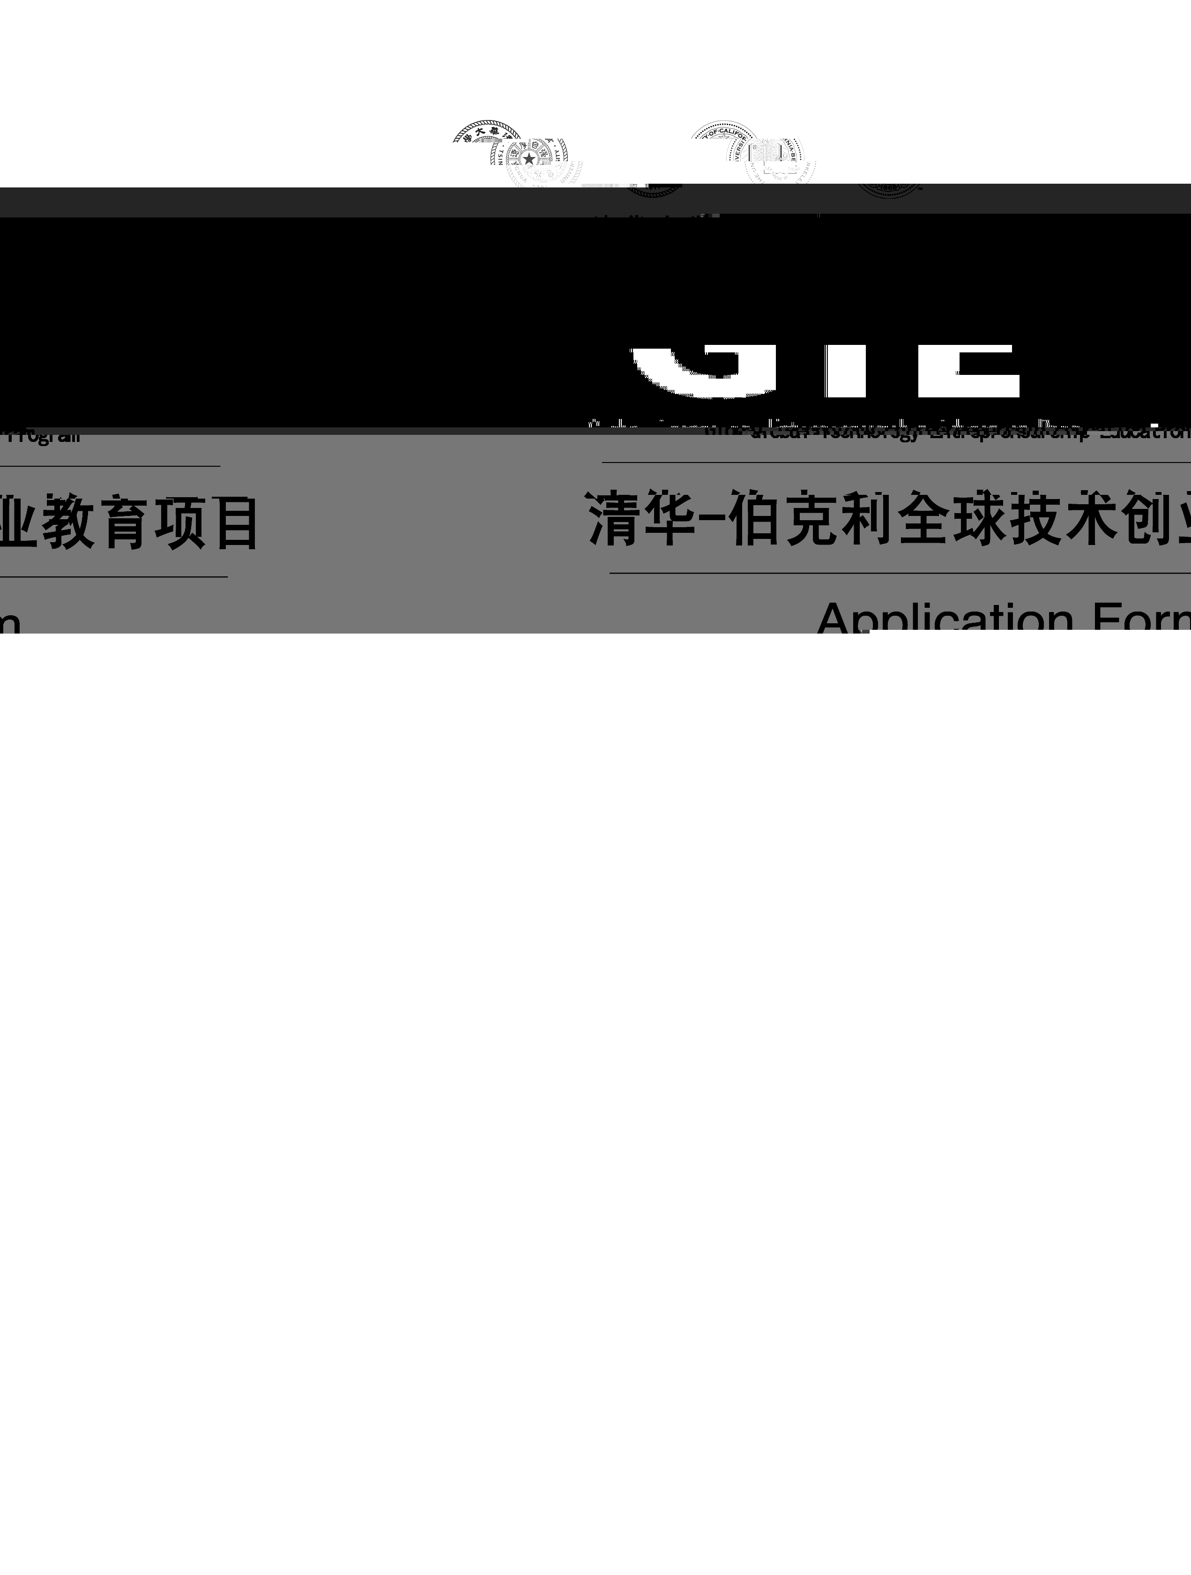

报名须知 / Notes for Applicants

为了使您的报名有效，请您如实填写报名表，并按要求提供所需文件，我们承诺对您所提供的信息严格保密。
1. 报名表
此申请表必须由申请人填写，各项填写内容要求完整清晰，并保证所填内容属实。如经核实发现造假行为，将取消报名资格。报名表请用中英文双语填写。
申请表将是筛选学生的关键性参考材料，请详细填写。
2. 证书
学历、学位、英语证书（CET6或以上 / GMAT / TOEFL / IELTS任一即可）的复印件各两份，具有多个学历学位的，应同时提供相关材料。
3. 附件
- 三张二寸照片（请提供半年以内的照片，并用铅笔在背面署名），其中一张按要求贴在报名表上。
- 身份证或护照复印件一份，按要求贴在报名表上。
- 中英文简历各二份。

Please provide accurate information on the application form. All information provided will be treated as strictly confidential.
1. Application Form
The application form must be completed by the applicant. The information that is given in support of this application must be accurate and true. Please provide a detailed application form. The interviewers will use it as a reference during selection.
The form must be completed in BOTH English and Chinese.

2. Certificates
Two copies of each of the certificates and the English qualifications ( CET6 / GMAT / TOEFL / IELTS ) that you have attained. If you have acquired a Master’s degree, please provide the relevant materials.

3. Attachments
1) Three recent photographs (2'×2') with your name printed on the back in pencil, one of which should be affixed to the application form.
2) One copy of your ID card or passport, which should be affixed to the application form.
3) Two copies of your resumes in both Chinese and English.

申请人声明Declaration

在此，我保证此申请表由我本人填写，一切信息属实。我理解并同意所有报名材料归学校所有，无论是否录取均不退回。
I declare that the information given in support of this application is accurate and complete, and I understand that the application materials that I submit will NOT be returned to me regardless of my acceptance into this program.

签名Signature 日期Date
申请者提交材料后，我们将根据以下各项核查所寄材料是否齐全，缺少任何材料都将视为申请无效。Checklist (Any missing information will render the application void)

报名申请表一份 | One copy of Application form
个人简历（中英文各二份） | Resumes (two in Chinese, two in English)
一份身份证或护照复印件（贴在报名表上） | One copy of ID card or passport
两份学位、学历复印件 | Two copies of degree certificates/diplomas
两份英语六级证书/GMAT/  TOEFL/IELTS复印件 | Two copies of CET6 or certificate(s) of your  English qualification (GMAT / TOEFL / IELTS)
三张二寸近照（背后署名,一张贴在报名表上） | Three recent photos (2'×2')

联系方式：

北京：
地址：北京市清华大学立斋305 邮编：100084
电话：86-10-6278 9757 传真：86-10-6278 9757
电子信箱：qinl2.04@sem.tsinghua.edu.cn

Contact us:

Tsinghua University
Address | Li Zhai 305, Tsinghua University  Beijing, 100084  P.R. China
P. C. | 100084
Tel | 86-10-6278 9757 Fax 86-10-6278 9757
Email | qinl2.04@sem.tsinghua.edu.cn

清华-伯克利全球技术创业教育项目报名表
The Tsinghua-Berkeley Global Technology Entrepreneurship Education Program Application Form

Please affix a
2'×2' recent
photo
请贴二寸近照

Please affix a copy of your ID card or passport
请贴上清晰的身份证或护照复印件

I．个人信息

姓名 拼音 性 别 □男 □女
出生日期 年 月 日 工作年限（年）____________
学院___________________ 专业___________________ 年级________________
学号____________________
联系电话 电子信箱

Ⅰ．Personal Information

Title □Mr. □Ms.
Last Name（Surname）
First Name
Identification Card Number□□□□□□□□□□□□□□□□□□
Date of Birth / / （dd/mm/yy） Years of work experience
Colleage_________ __________ Major ___________________ Grade________________
Student Number____________________
Cell Phone No.
E-mail Address

II．教育背景（从最高学位起始）
Education（please list your highest degree first）

学校  Institution | 专业  Major | 学位  Degree Attained | 学历  Qualification | 起止时间（年/月）  Periods（Month/Year）
从（From）＿＿＿＿＿
至 (To) ＿＿＿＿＿
从（From）＿＿＿＿＿
至 (To) ＿＿＿＿＿
从（From）＿＿＿＿＿
至 (To) ＿＿＿＿＿
从（From）＿＿＿＿＿
至 (To) ＿＿＿＿＿
III.请您回答以下问题 Please answer the following questions

- 请说明您为什么决定申请本项目，您期望从本项目当中学到什么？（不超过200字）
In fewer than 200 words, please specify why you have decided to apply for this program. What do you
expect to learn from this program?

- 请用五句话描述您的个人特点。
In not more than 5 sentences, please elaborate on why you should be selected for the program.

- 请详细描述您认为可以成功的创业理念，拟开展的一项技术创新和创业活动。解释您想解决的问题。谁有这个问题？解释任何其他解决方法（直接和间接的竞争对手）。描述您相关的技能或背景。（字数不超过2000字，如需要，可另附纸）
In fewer than 2000 words, please give an example of a business idea – a technological innovation and entrepreneurial activity – that you feel can be successful. Explain the problem that you are solving. Who has this problem? Explain any other ways that the same problem can be solved (direct and/or indirect competitors). What skill or background do you have that is relevant?

评价（由清华-伯克利项目办公室填写)：
Comments: (To be completed by the office)

